Name - Krishnaprasad Awala

Enrollment no – MITU21BTITD006

Rolll no - D2215004

**Q. You are working on a project where the team is using the Six Sigma process model to identify and eliminate defects in the software development process. How would you ensure that the focus on quality is maintained while still meeting project deadlines?**

→

Six Sigma is a data-driven approach to quality improvement that aims to identify and eliminate defects in a process by using statistical methods.

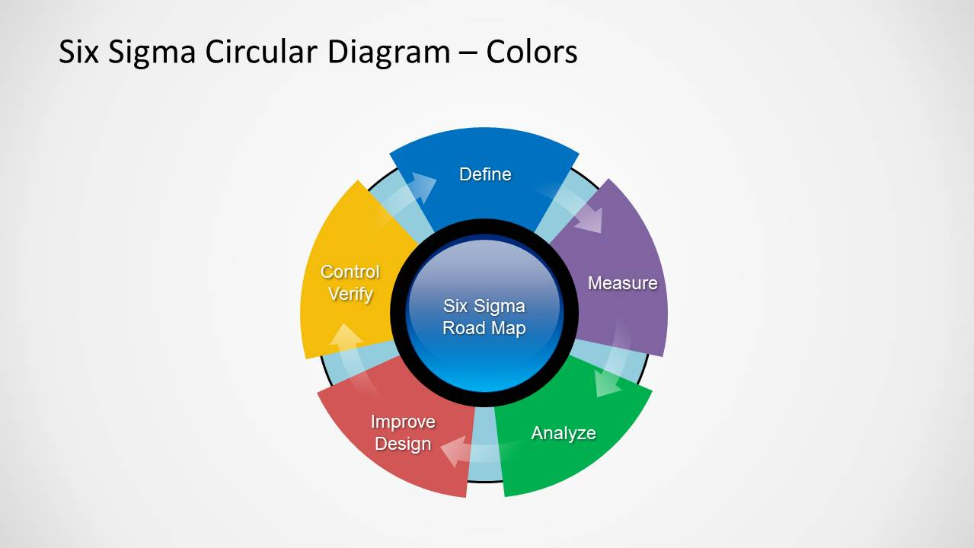

While Six Sigma can be a powerful tool for improving software development processes, it is important to balance the focus on quality with the need to meet project deadlines. Here are some ways to ensure that the focus on quality is maintained while still meeting project deadlines:

Balancing quality and deadline in six sigma software development  → Set Realistic goals and expectations → Prioritize quality → Use data to drive decisions → involve stakeholders → Empower the team → Continuously improve

**Set realistic goals and expectations:** One of the keys to balancing quality and deadlines is to set realistic goals and expectations from the outset. This means that project deadlines should be set based on a realistic assessment of the time required to complete each task, and the quality standards should be clearly defined and communicated to the team.

**Prioritize quality:** Quality should be a top priority for the project, and the team should be encouraged to take the time to do things right the first time. This may mean that deadlines need to be adjusted to allow for additional testing or review.

**Use data to drive decisions:** Six Sigma is a data-driven approach, so it is important to use data to make informed decisions about the project timeline. This means tracking metrics such as defect rates, cycle time, and customer satisfaction, and using this data to identify areas for improvement.

Involve stakeholders: It is important to involve stakeholders in the project, including customers, sponsors, and end-users. This can help ensure that quality remains a top priority, and that the team is working towards a common goal.

**Empower the team:** The team should be empowered to make decisions and take ownership of the process. This can help ensure that the team is invested in the project and committed to delivering high-quality software.

Continuously improve: Six Sigma is a continuous improvement process, so it is important to continuously monitor and improve the software development process. This means using feedback from stakeholders, tracking metrics, and making adjustments as necessary to ensure that the project is on track to meet both quality and deadline goals.

By following these tips, it is possible to maintain a focus on quality while still meeting project deadlines using the Six Sigma process model in software development.